LAB 9: EXCEPTION HANDLING IN JAVA

Name: Shreyas Sawant Div: D7A Roll No.: 55

Q. 1.  Write a program to demonstrate the concept of multiple catch statements.

CODE:

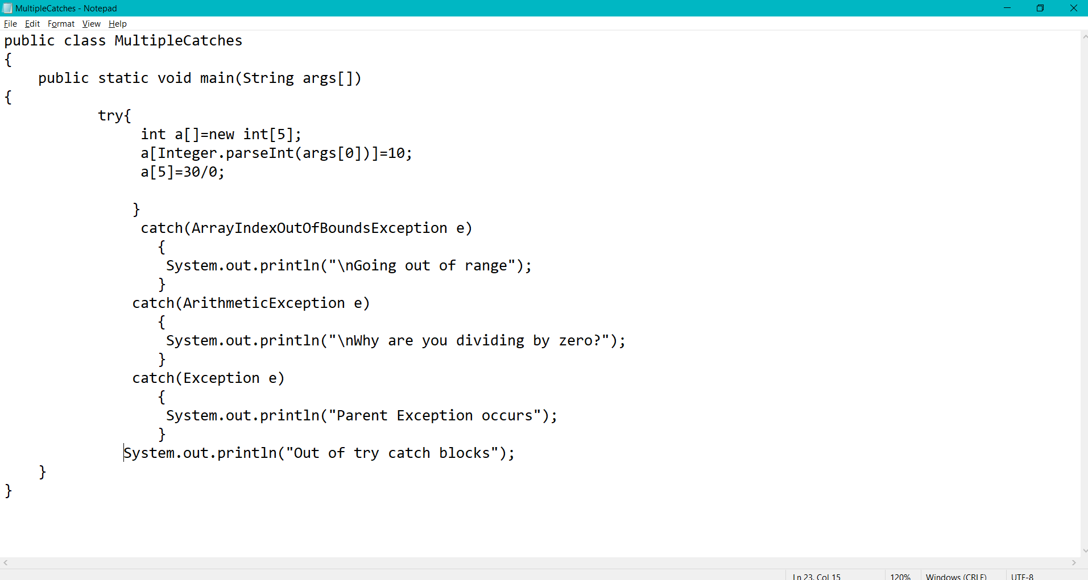

OUTPUT:

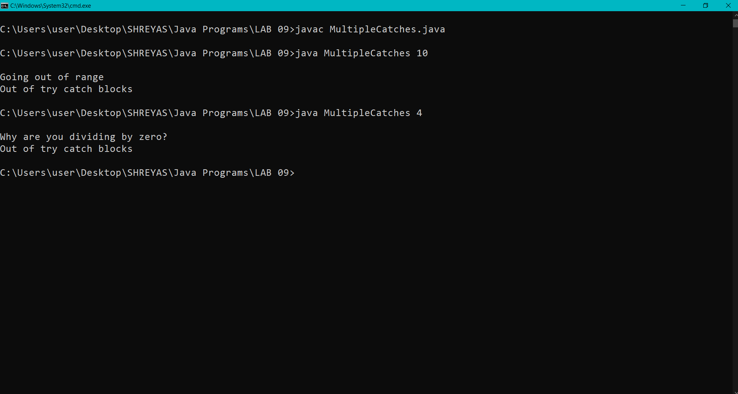

Q.2. Write a program to demonstrate the working/importance of finally block.

CODE:

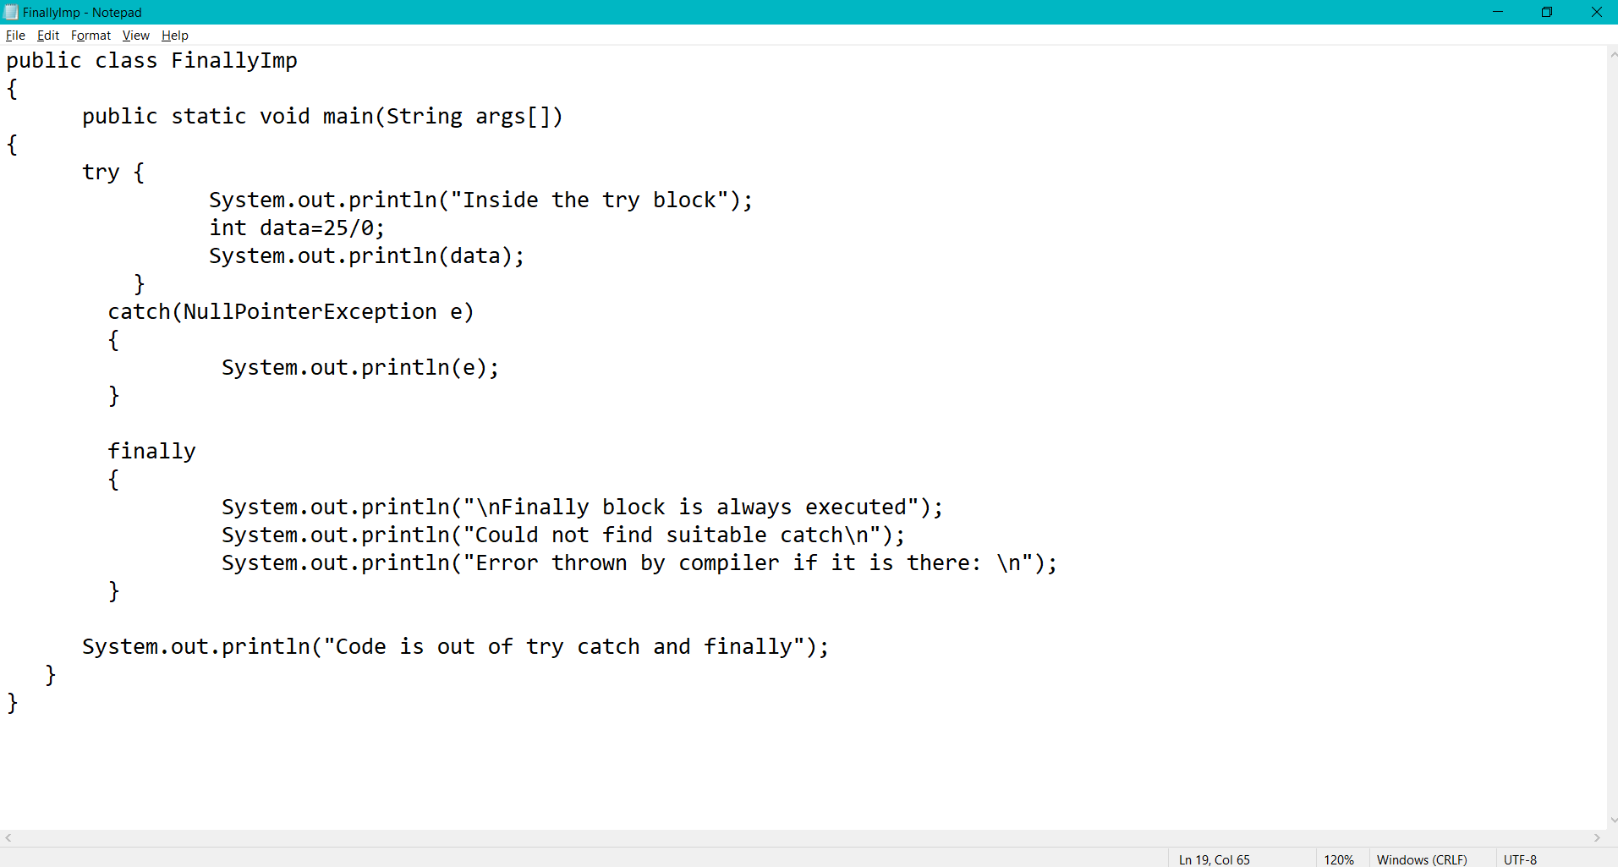

OUTPUT:

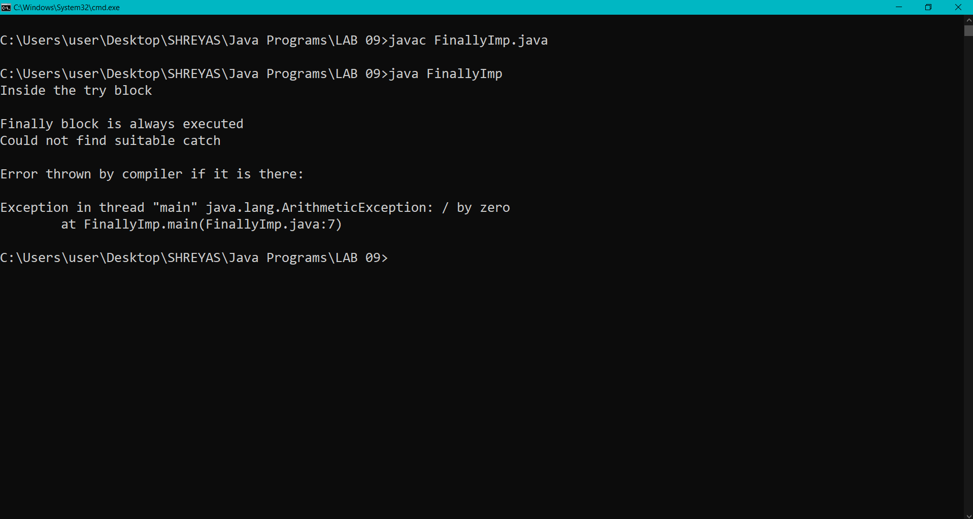

Q.3. Write a program to create a user defined exception to calculate the result. The result should consist of name, seat no, date, centre no and marks of 3 semesters. Create a user defined exception class MarksOutOfBoundsException. If entered marks of any subject is greater than 100 or less than 0 then program should create a user defined exception of the type MarksOutOfBoundsException and must have a provision to handle it.

CODE:

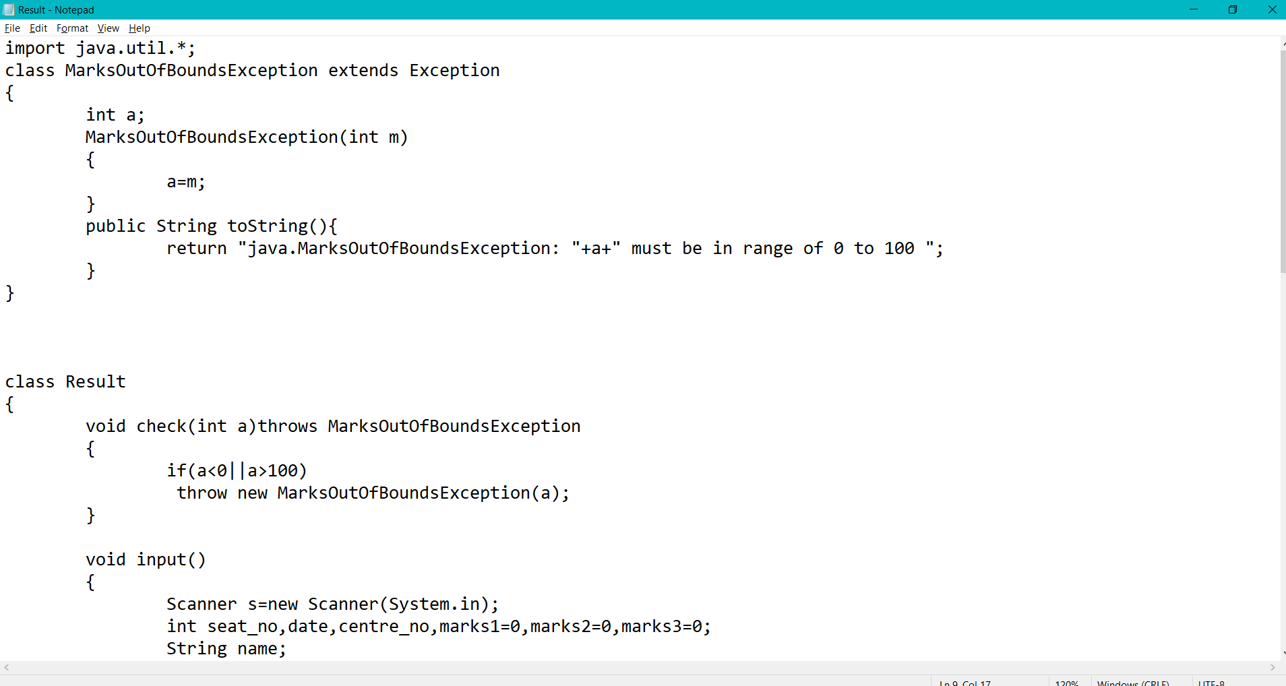

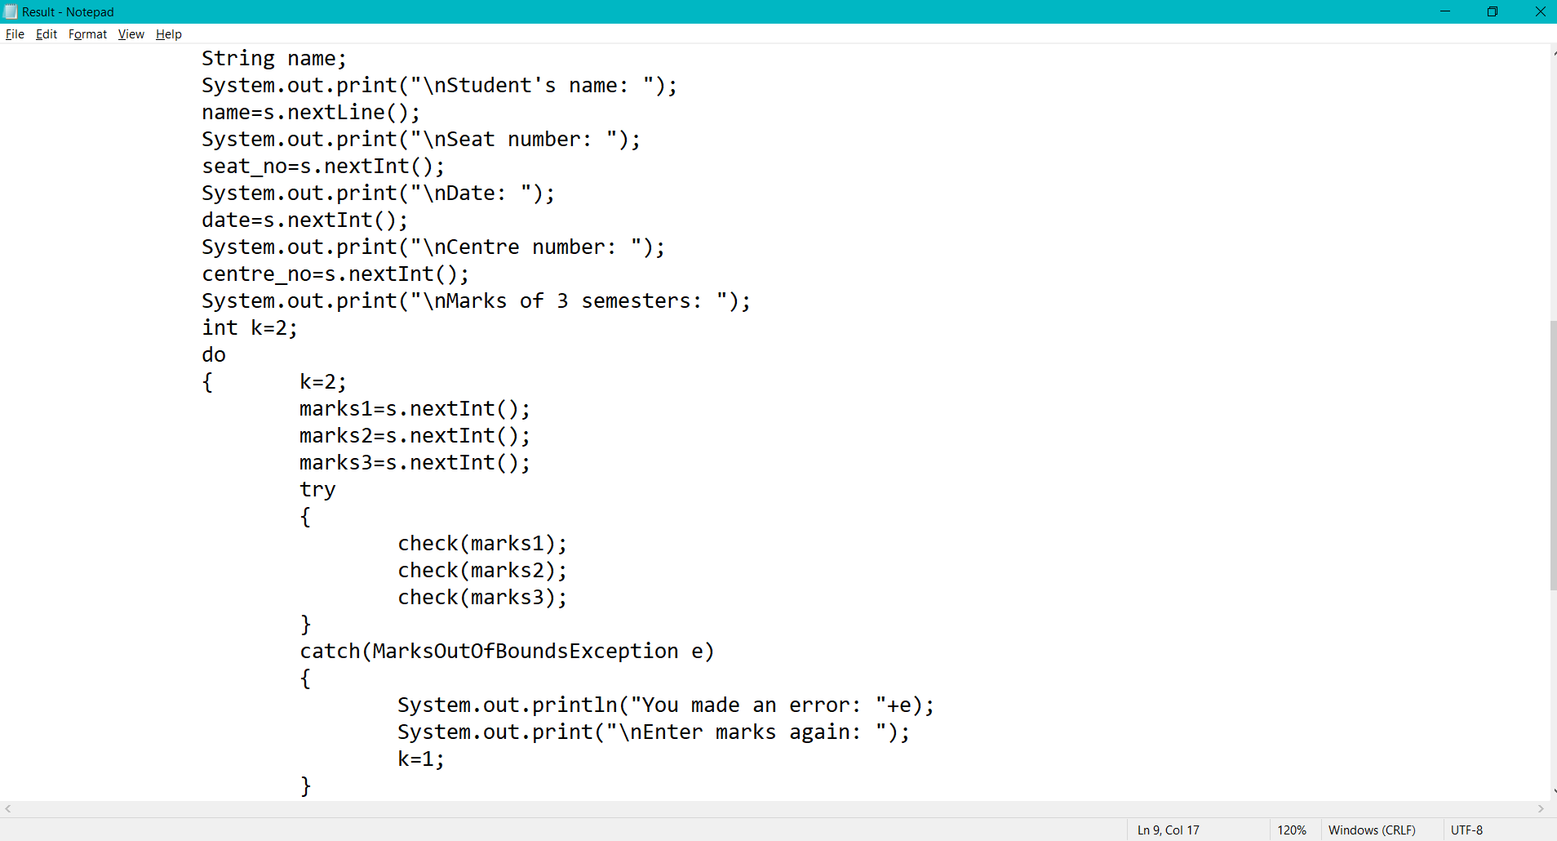

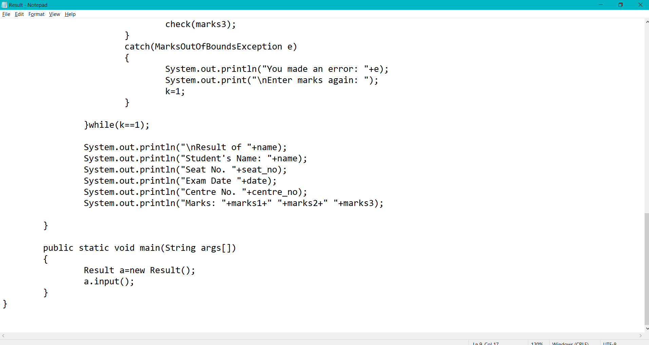

OUTPUT:

